**Cost based optimization**

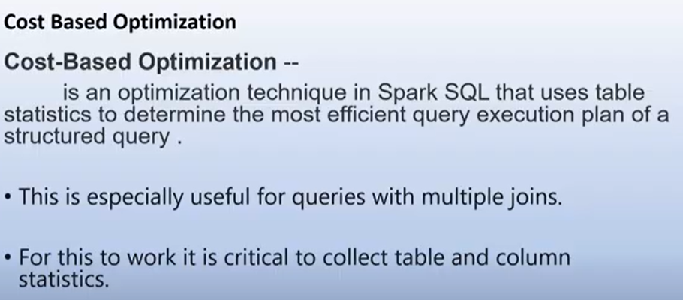

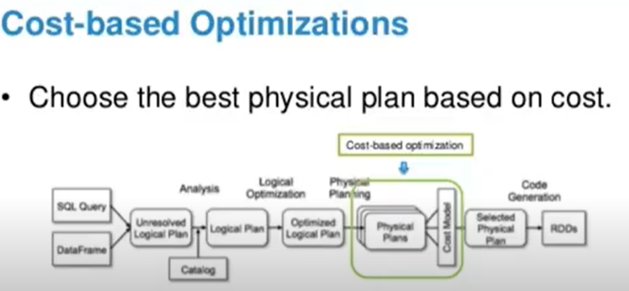

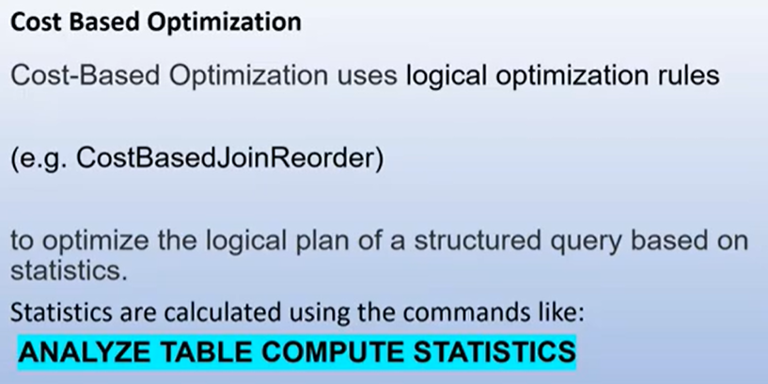

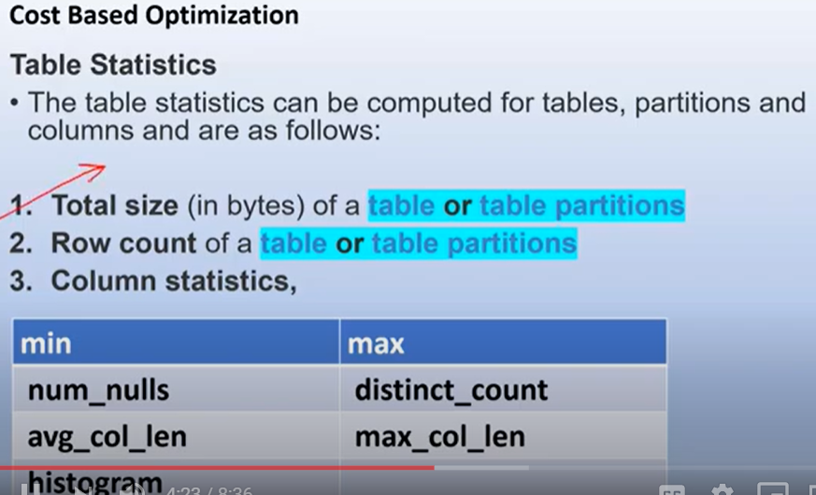

Be default the cost based analysis is disabled(CBO), we try this example and look at the query execution plan on spark UI.

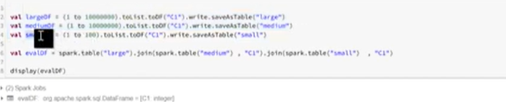

In this we enable cost based optimizer, the query execution plan is reader and also the exection time is less from the above

